Name: Ayush Chanchal

Sap id: 500097569

Batch: B6

*EXPERIMENT: 7*

IMPLEMENTATION OF CNN

Q). WHAT IS CNN?

CNN stands for Convolutional Neural Network. It is a type of artificial neural network used in machine learning, particularly well-suited for tasks related to image and video recognition, as well as other grid-like data. CNNs are designed to automatically and adaptively learn patterns from data through a process known as convolution.

Here are some key components and concepts associated with CNNs:

1. Convolution: In a CNN, convolution is the core operation. It involves passing a small filter (also called a kernel) over the input data to extract local patterns. These patterns can represent features like edges, textures, or more complex structures. Convolutional layers help reduce the number of parameters and allow the network to focus on local patterns.

2. Pooling: Pooling layers are used to downsample the spatial dimensions of the data. The most common type of pooling is max pooling, which retains the maximum value from a small region of the input. Pooling helps reduce the computational burden and makes the network more robust to variations in input.

3. Convolutional Layers: These layers consist of multiple convolution operations, followed by activation functions, which introduce non-linearity into the network. Convolutional layers extract hierarchical features from the input data.

4. Fully Connected Layers: After several convolutional and pooling layers, CNNs often have one or more fully connected layers that are similar to traditional neural networks. These layers help in making predictions or classifications based on the features learned in the earlier layers.

5. Activation Functions: Common activation functions used in CNNs include ReLU (Rectified Linear Unit) and its variants. These functions introduce non-linearity and allow the network to learn complex patterns.

CNNs are widely used in tasks such as image classification, object detection, facial recognition, and even in more complex applications like natural language processing when dealing with sequential data (using methods like 1D convolutions). They have revolutionized the field of computer vision and are a fundamental technology in deep learning.

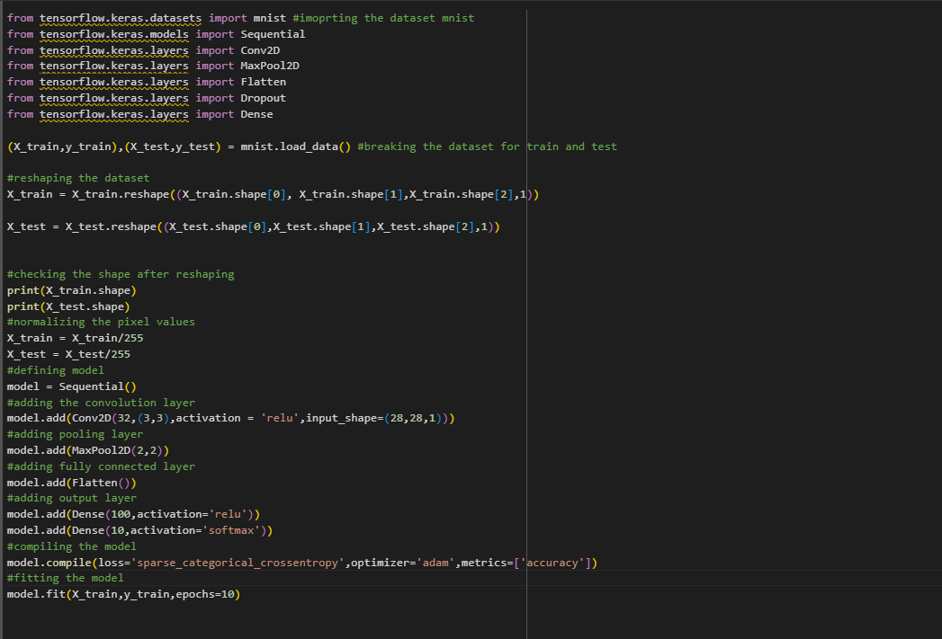IMPLEMENTATION:-

